CREATING AN LIBRARY DATABASE USING SQL THROUGH ORACLE SERVER

A Case Study submitted by:

*S Sri Harsha Teja*, VU22CSEN0101809

*G Praneeth*, VU22CSEN0101844

*U Sai Rahul*, VU22CSEN0101745

*K Manas Srikar*, VU22CSEN0101616

*Akhil Malla*, VU22CSEN0101649

Under the esteemed guidance of Mrs. P. Manasa Devi Assistant Professor



## DEPARTMENT OF COMPUTER SCIENCE & ENGINEERING GITAM

(Deemed to be University) OCTOBER 2024

## DEPARTMENT OF COMPUTER SCIENCE & ENGINEERING GITAM

(Deemed to be University) OCTOBER 2024



**DECLARATION**

I/We hereby declare that the case study entitled “**CREATING AN ONLINE RETAIL DATABASE USING SQL THROUGH ORACLE SERVER”** is an

original work done in the Department of Computer Science and Engineering, GITAM School of Technology, GITAM (Deemed to be University) submitted in partial fulfillment of requirements of completing the course of CSEN2061- DATABASE MANAGEMENT SYSTEM LAB. The work hasn’t been lend to any other team or Individual.

## DATE:

**TEAM DETAILS:**

|  |  |  |  |
| --- | --- | --- | --- |
| **S.NO** | **REGD.NO** | **NAME** | **SIGNATURE** |
| 1 | VU22CSEN0101809 | S Sri Harsha Teja |  |
| 2 | VU22CSEN0101844 | GVNSS  Praneeth |  |
| 3 | VU22CSEN0101745 | U Sai Rahul |  |
| 5 | VU22CSEN0101808 | K Manas Srikar |  |

|  |  |  |  |
| --- | --- | --- | --- |
| 6 | VU22CSEN0101649 | Akhil Malla |  |

## DEPARTMENT OF COMPUTER SCIENCE & ENGINEERING GITAM

(Deemed to be University) OCTOBER 2024



## CERTIFICATE

This is to certify that the following case study entitled “**CREATING AN ONLINE LIBRARY DATABASE USING SQL THROUGH ORACLE**

**SERVER”** is a bonafide record done by

*S Sri Harsha Teja*, VU22CSEN0101809

*G Praneeth*, VU22CSEN0101844

*U Sai Rahul*, VU22CSEN0101745

*K Manas Srikar*, VU22CSEN0101616

*Akhil Malla*, VU22CSEN0101649

submitted in partial fulfillment of requirements of completing the course of CSEN2061- DATABASE MANAGEMENT SYSTEM LAB.

PROJECT GUIDE HEAD OF THE DEPARTMENT

Mrs. P. MANASA DEVI GONDI LAKSHMEESHWARI ASSISTANT PROFESSOR

|  |  |  |
| --- | --- | --- |
|  | Table of Contents |  |
| Absract |  | 4 |
| Part-1 |  | 6-9 |
| ER Model |  | 7 |
| Conceptual Schema |  | 8 |
| Part-2:Relational Mode  Relational Model DDL Commands |  | 9-16  9 |
| DML Commands |  | 10 |
| DCL Commands |  | 12 |
| TCL Commands |  | 12 |
| DQL Command |  | 12 |
| Part-3:Advanced SQL |  | 16-18 |
| Nested Queries |  | 16 |
| Correlated Queries |  | 16 |
| Aggregate Operators |  | 17 |
| Relational Operators |  | 17 |
| Part-4:Joins And Views |  | 18-24 |
| Joins |  | 18 |
| Views |  | 19 |
| Display Table |  | 19 |

# Abstract

The aim of this Case Study is to create a database of online retail websites using SQL in Oracle. We will briefly look into what online retail is:

Online retail is a type of eCommerce whereby a business sells goods or services directly to consumers from a website. The website may be their own, or it may be owned by a larger retailer or marketplace like Amazon. Online retail is a similar concept to brick-and-mortar retail. Shoppers enter the store, search through an organized inventory of products, and then pay for their goods at

checkout. It’s just that online retail takes place over the Internet while brick- and-mortar is done in person.

Objectives of the Study This study aims to:

Develop a Structured Database: Create a database schema that organizes various online retail platforms and their attributes.

Utilize SQL for Data Management: Implement SQL commands to define tables, relationships, and constraints relevant to online retail data.

Analyze Data Trends: Use SQL queries to extract insights regarding consumer behavior and market trends from the database.

Methodology

The research will involve:

Database Creation: Utilizing Oracle SQL commands such as CREATE DATABASE and CREATE TABLE to establish the database structure.

Data Insertion: Populating the database with relevant data about online retailers, including product categories, pricing, and customer reviews.

Query Execution: Running SQL queries to analyze and retrieve data for further insights into online retail dynamics.

Significance of the Study

Understanding the landscape of online retail through a structured database is crucial for businesses aiming to optimize their eCommerce strategies. By

leveraging Oracle SQL, this study will provide valuable insights that can help stakeholders make informed decisions regarding product offerings, marketing strategies, and customer engagement practices.

In summary, this case study will contribute to the broader understanding of online retail dynamics and assist businesses in navigating the complexities of the digital marketplace through effective database management.

PART-1:

ER MODEL

# CONCEPTUAL SCHEMA :

BOOKS(book_id: PrimaryKey, title: varchar2, isbn: varchar2, published_date: date, price: number, category_id: ForeignKey, publisher_id: ForeignKey);

CATEGORIES(category_id: PrimaryKey, category_name: varchar2);

PUBLISHERS(publisher_id: PrimaryKey, name: varchar2, address: varchar2);

AUTHORS(author_id: PrimaryKey, first_name: varchar2, last_name: varchar2);

BOOK_AUTHORS(book_id: ForeignKey, author_id: ForeignKey);

READERS(reader_id: PrimaryKey, first_name: varchar2, last_name: varchar2, address: varchar2, phone: varchar2);

STAFF(staff_id: PrimaryKey, first_name: varchar2, last_name: varchar2, position: varchar2);

LOGINS(login_id: PrimaryKey, username: varchar2, password: varchar2, reader_id: ForeignKey, staff_id: ForeignKey);

BOOK_ISSUE(issue_id: PrimaryKey, book_id: ForeignKey, reader_id: ForeignKey, issue_date: date, return_date: date, staff_id: ForeignKey);

BOOK_RETURN(return_id: PrimaryKey, book_id: ForeignKey, reader_id: ForeignKey, return_date: date, staff_id: ForeignKey);

BOOK_RESERVE(reserve_id: PrimaryKey, book_id: ForeignKey, reader_id: ForeignKey, reserve_date: date);

PUBLISHES(publisher_id: ForeignKey,book_id: ForeignKey)

BOOK_MANAGEMENT(book_id:ForeignKey,staffid:ForeignKey,managemt date:Date)

BOOK_TRANSACTION(transactionid:PrimaryKey,book_id:ForeignKey,staff_id:ForeignKey)

PART-2:

RELATIONAL MODELS: DDL COMMANDS

Creating Tables

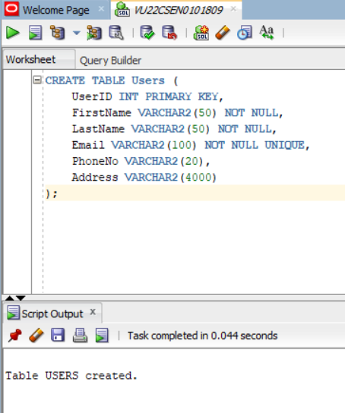

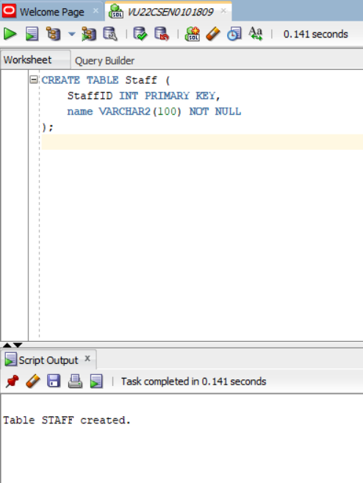

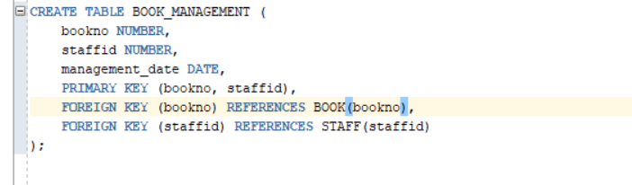

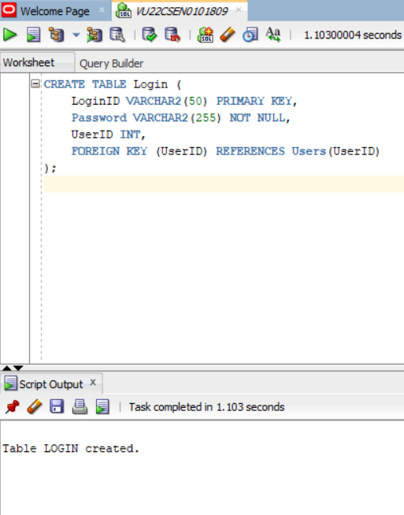

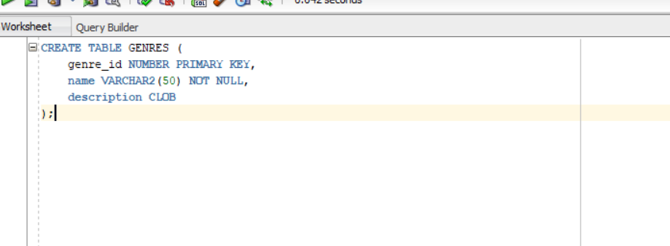



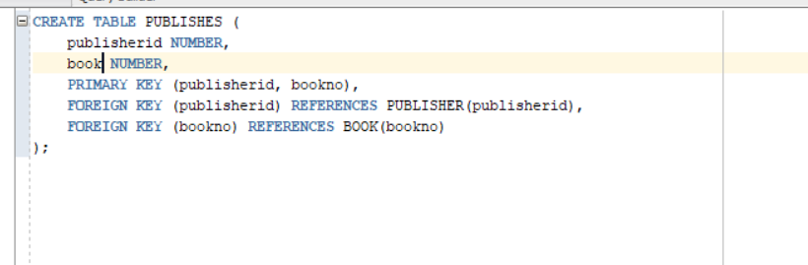

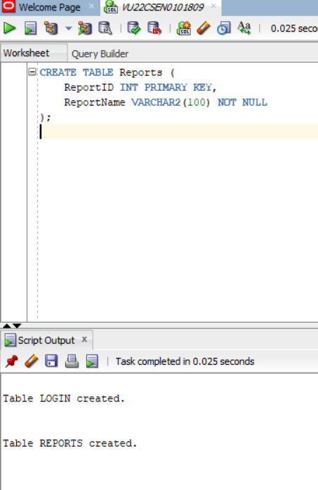

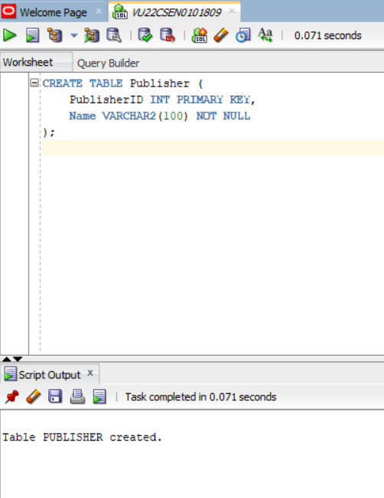

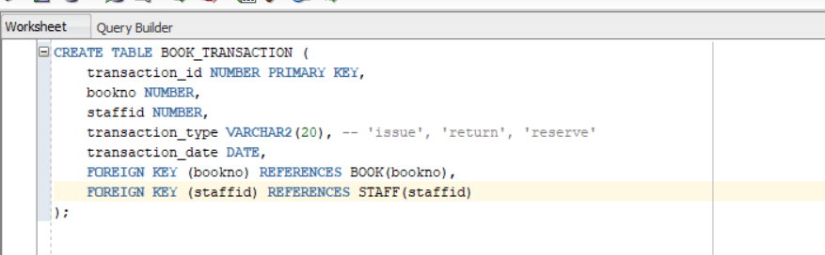

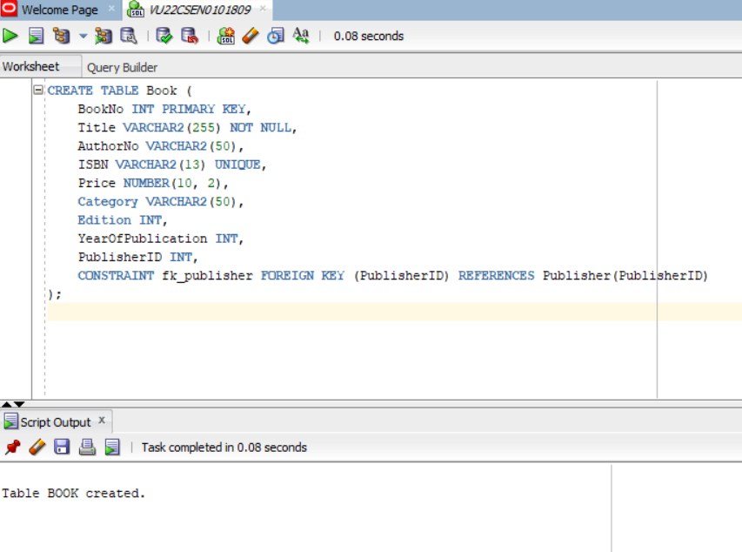

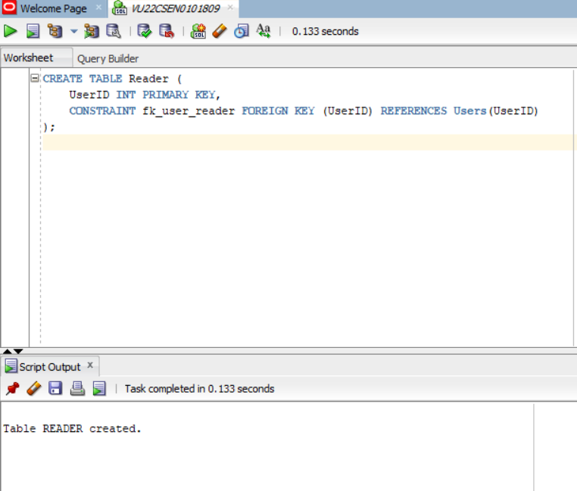

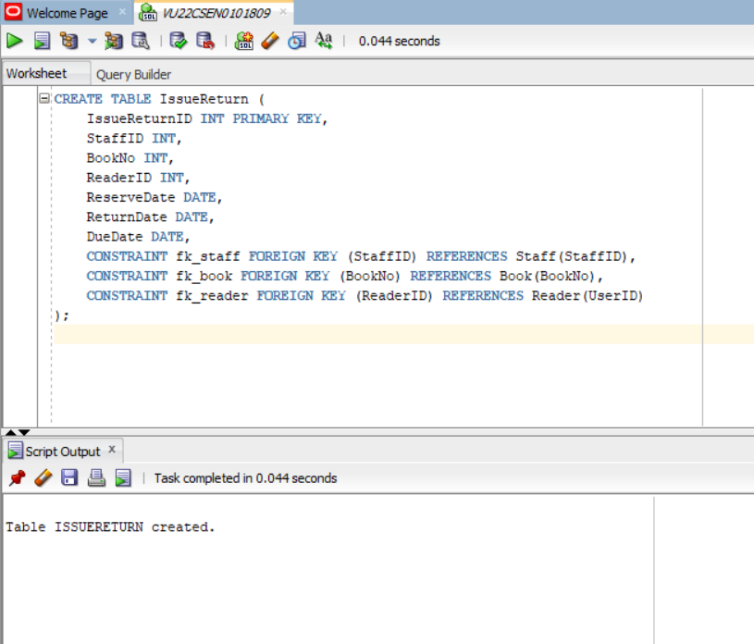

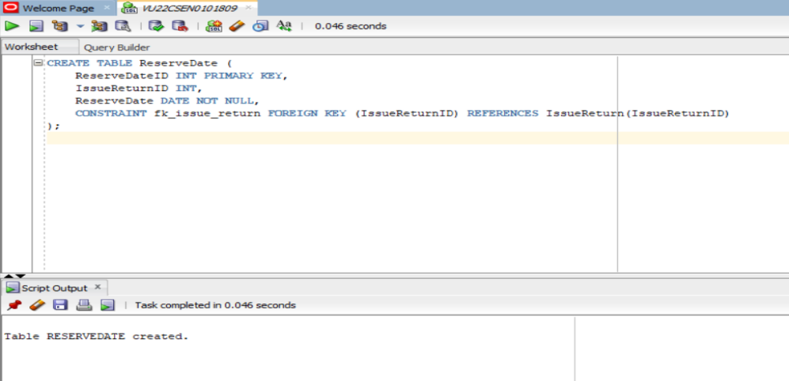

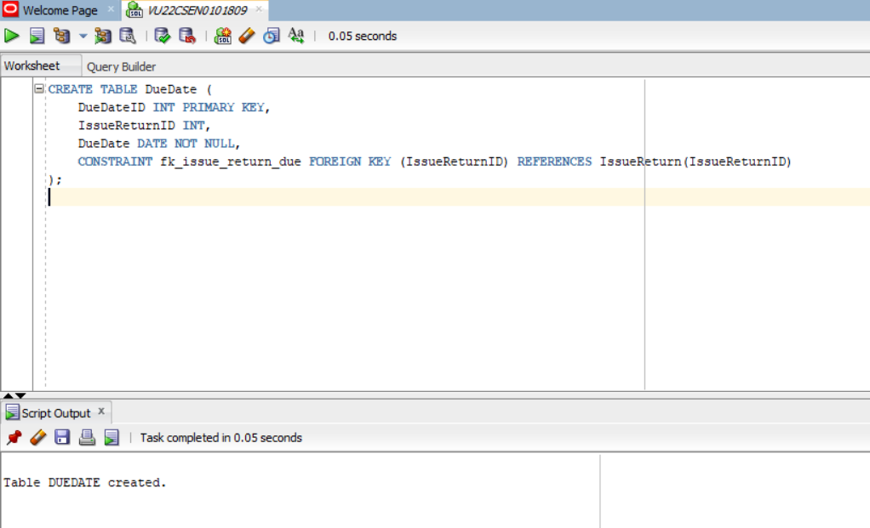

# DML COMMANDS:

Inserting data into Tables using INSERT INTO command

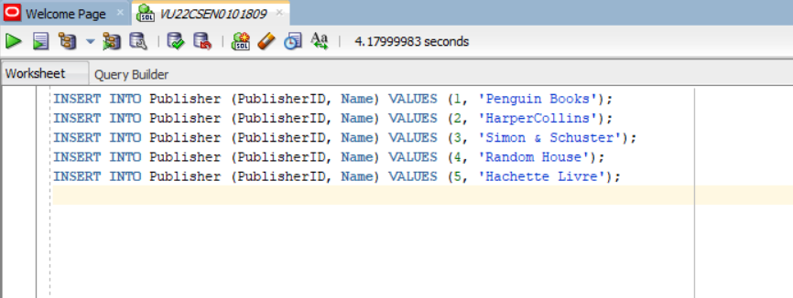

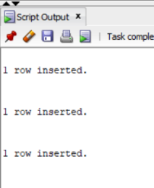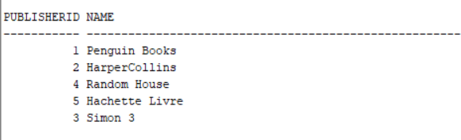

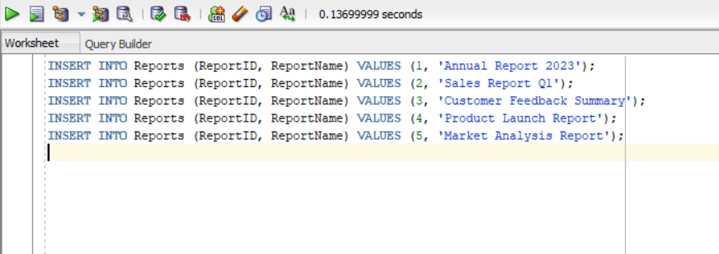

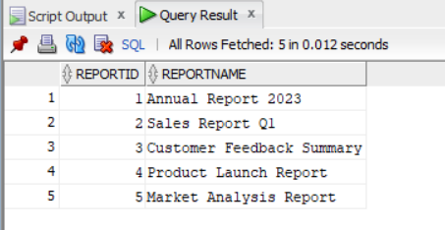

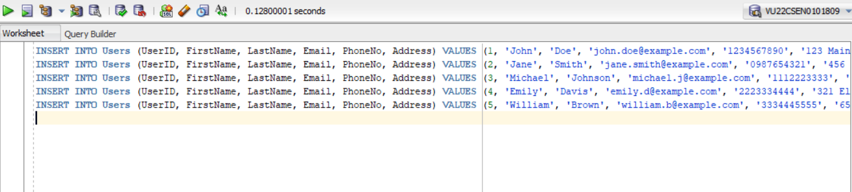

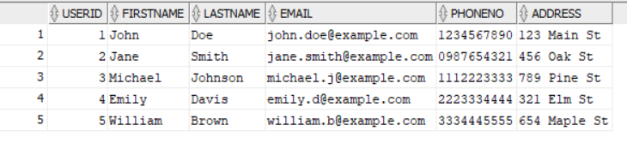

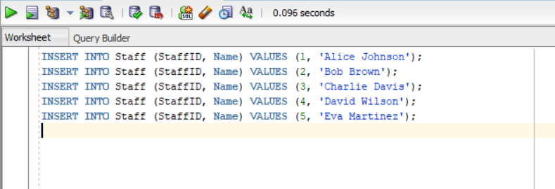

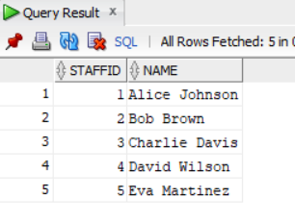

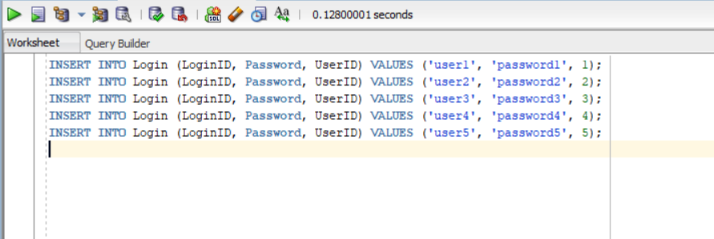

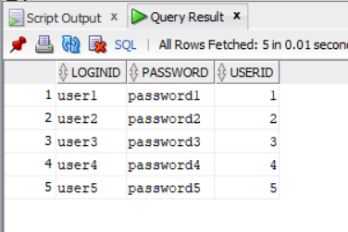

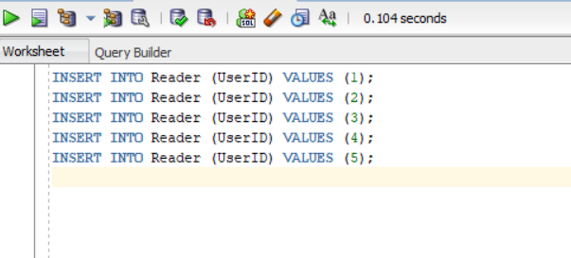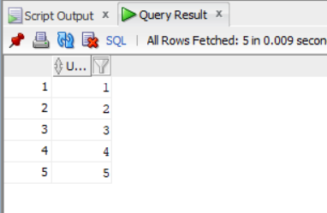

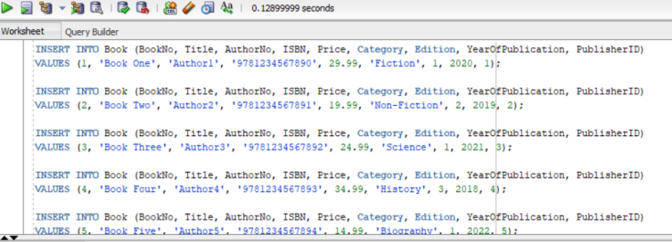

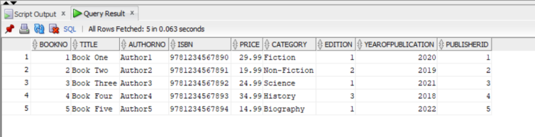

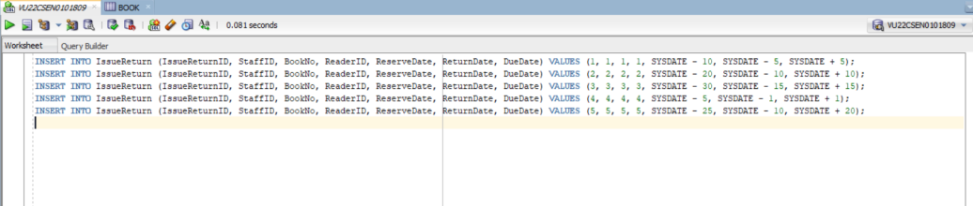

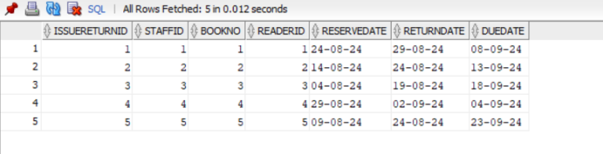

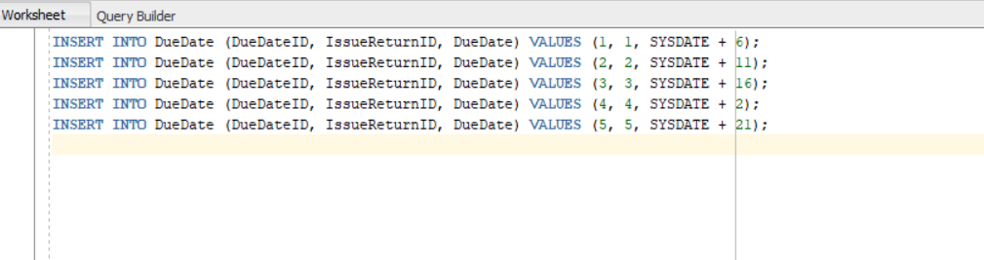

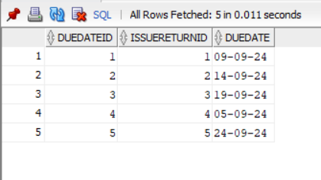

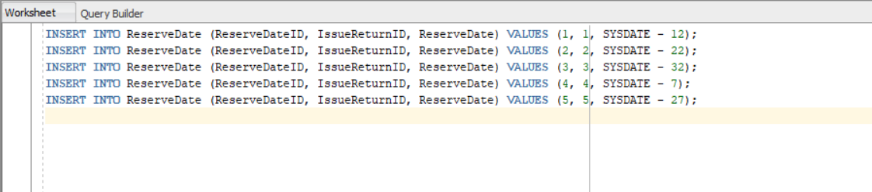

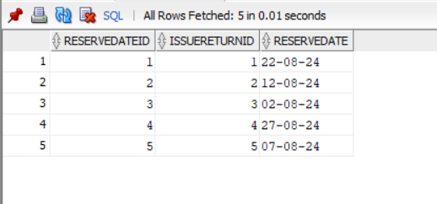

**SELECT COMMAND :**1) SELECT WITH HAVING :  
Retrieving the publisher id and count of books for each publisher.

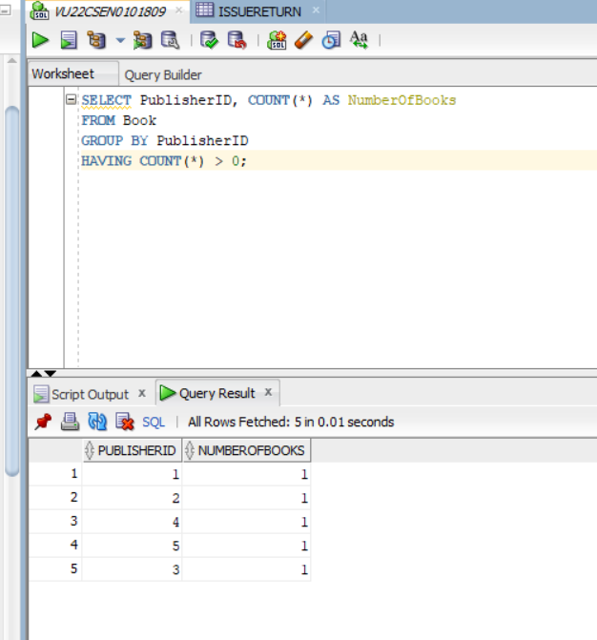

2)SELECT using Sub Query  
Retrieving first and last name for each user.  
  
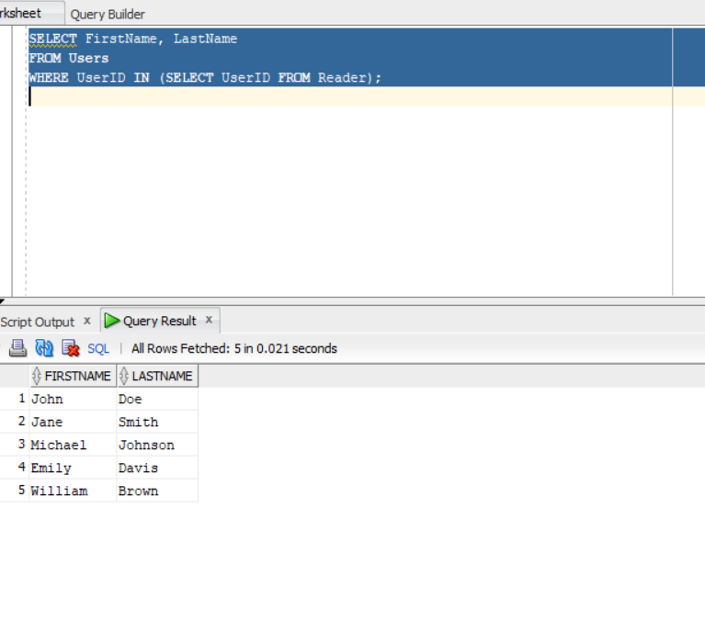

3) SELECT using Union   
  
Retrieves the first and last name and gives as one.  
  
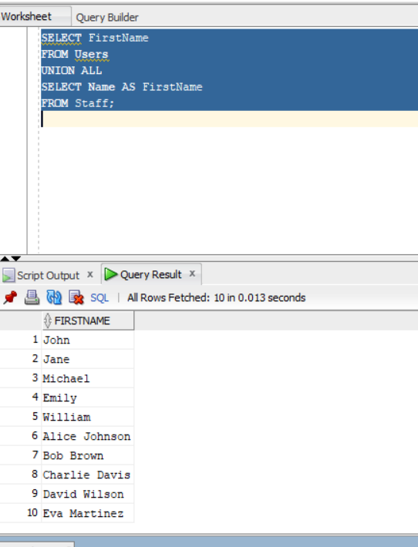

4)SELECT WITH INNER JOIN   
  
User’s first name along with the books they have taken.  
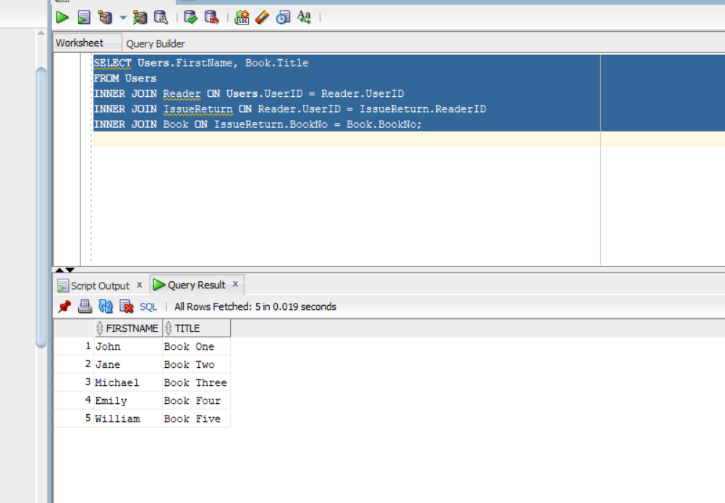

5) SELECT WITH GROUP BY  
  
Number of books associated with each publisher.  
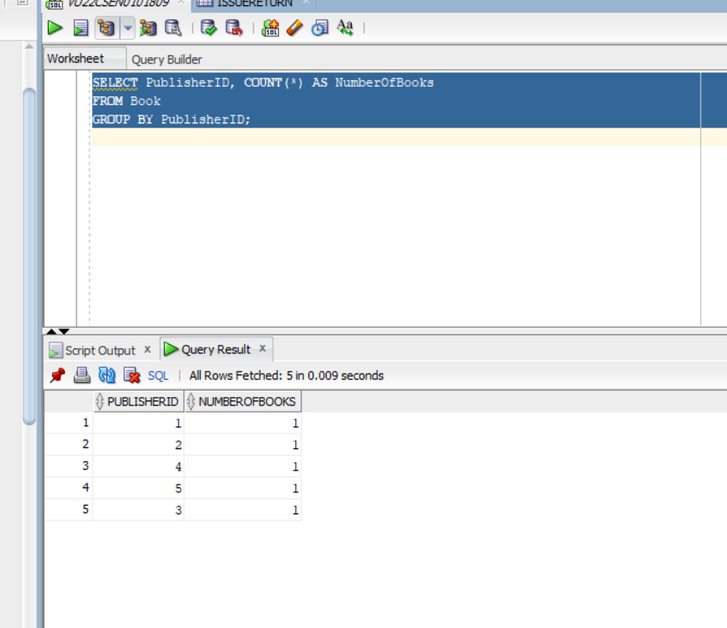

**PART-3:Advanced SQl**

a)Nested Queries:

Find the top 3 most expensive books along with their publishers' names.

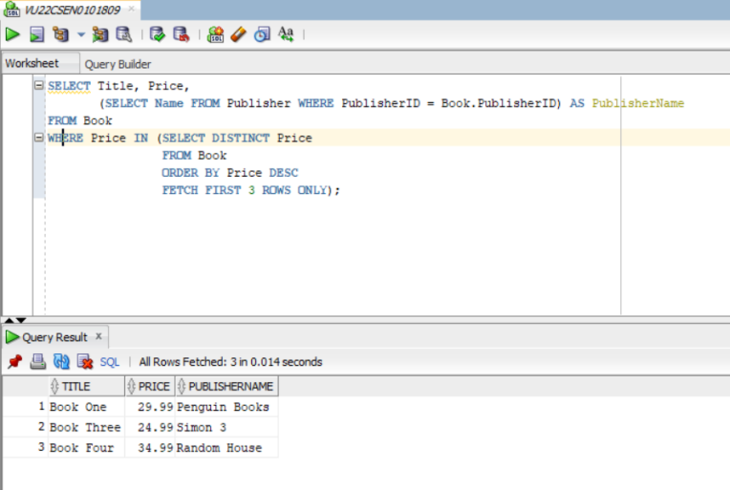

Books in the Top 25% by Price

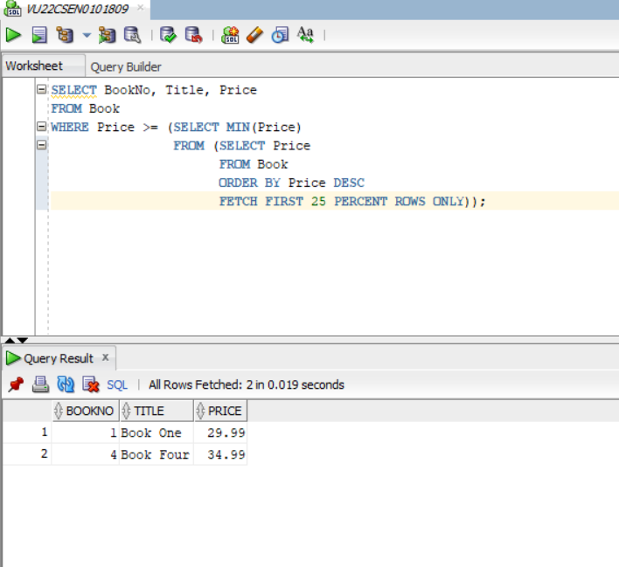

b)Correlated Queries:

1.Find Books with the Highest Price in Each Category

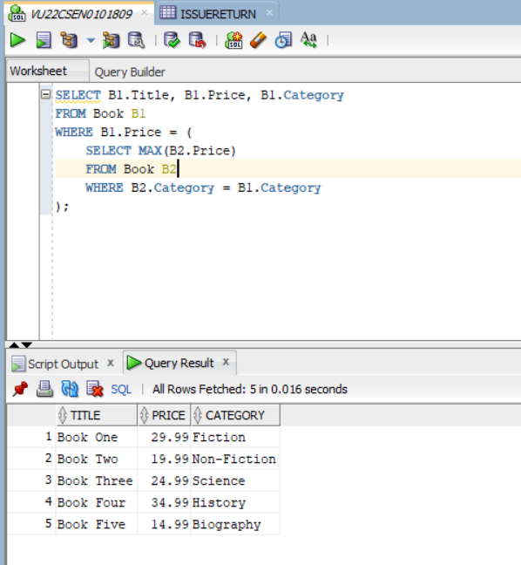

Find Users Who Have Borrowed Books with the Latest ReserveDate

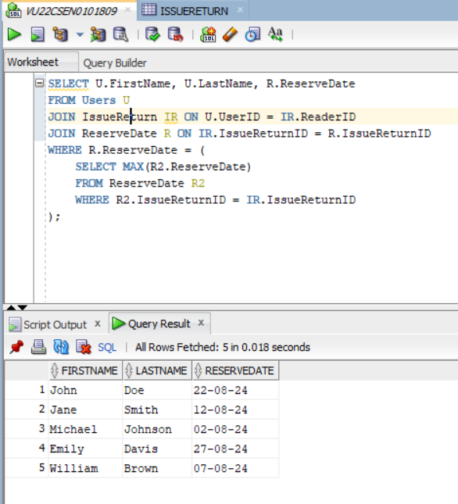

c)Aggregate operators:

1. Total Number of Books in Each Category

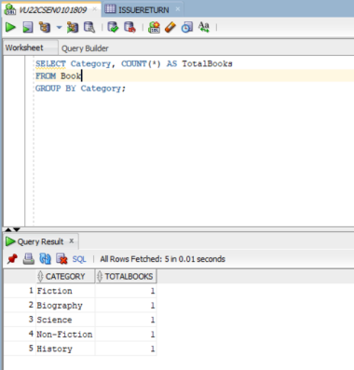

2. Average Price of Books in Each Category

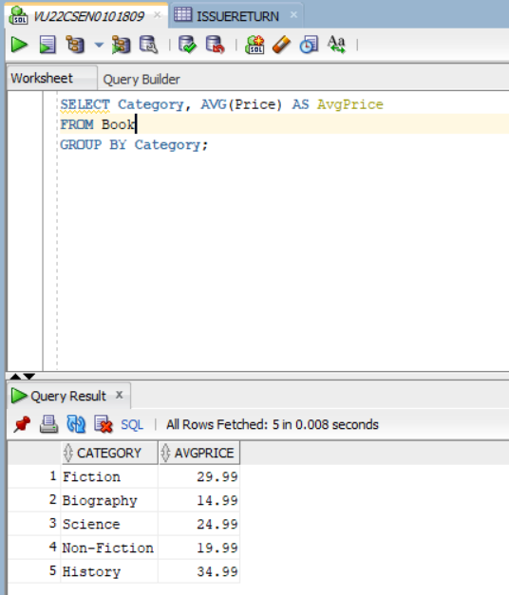

3. Maximum and Minimum Prices of Books

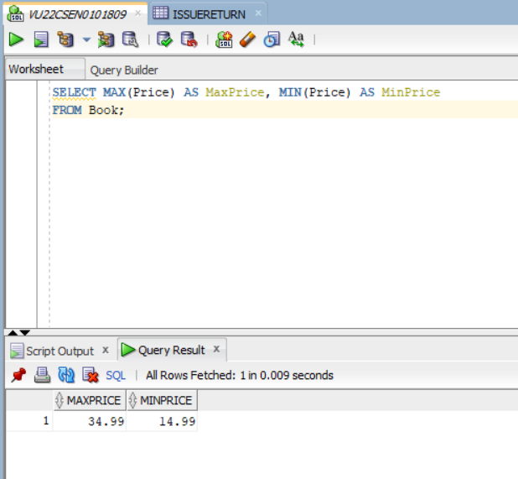

4. Count of Readers Who Have Issued Books

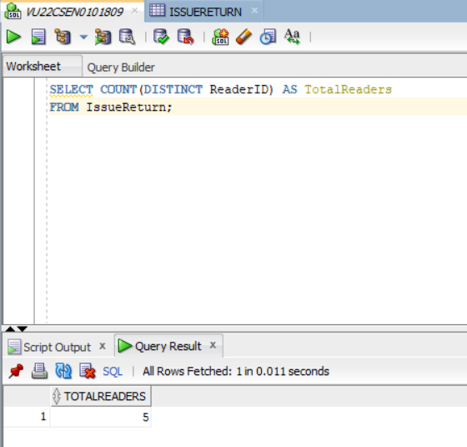

d) Set comparision operations Queries:

1.Find All Readers and Staff (Union)

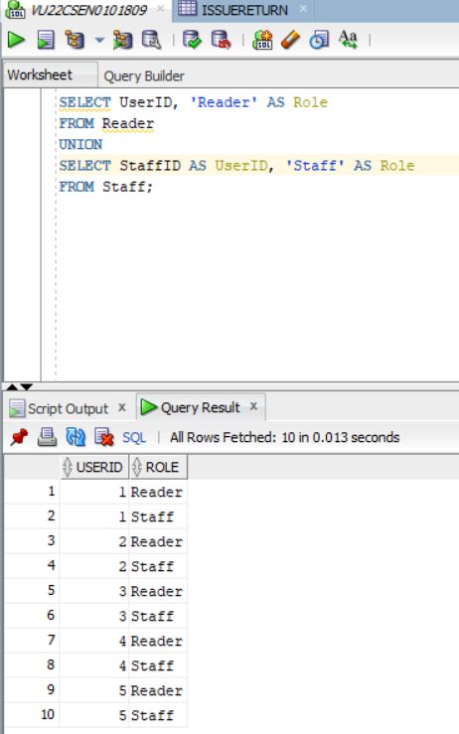

2. Find All Books With Prices Below Average (Subquery with Aggregate)

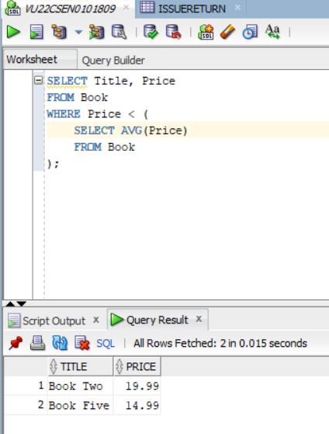

e)Relation set operators:

1.Find Authors in Fiction but Not in Science

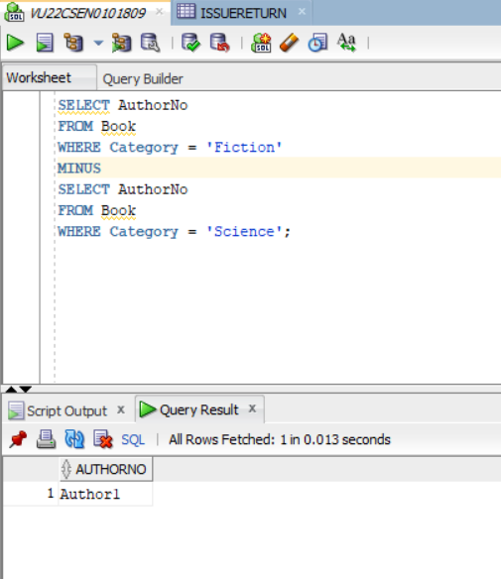

2.Union of All Categories

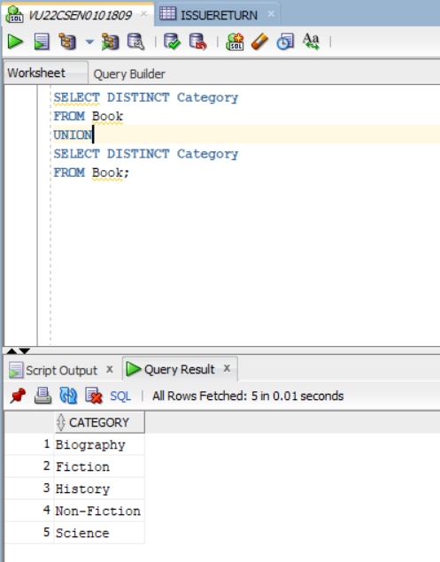

**PART-4:Joins and Views**

Joins 1 : Get Books Issued by Each Reader with Staff Details  
  
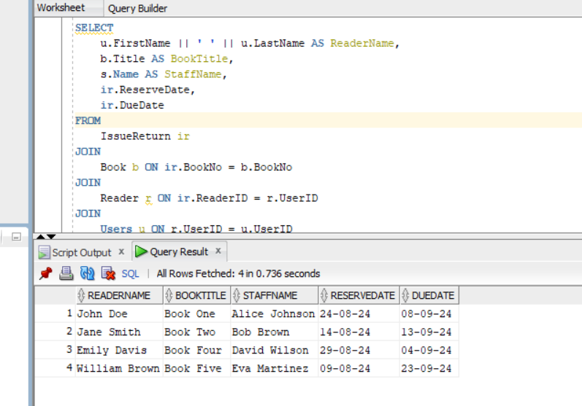

Join 2 : List All Books with Publisher Information  
  
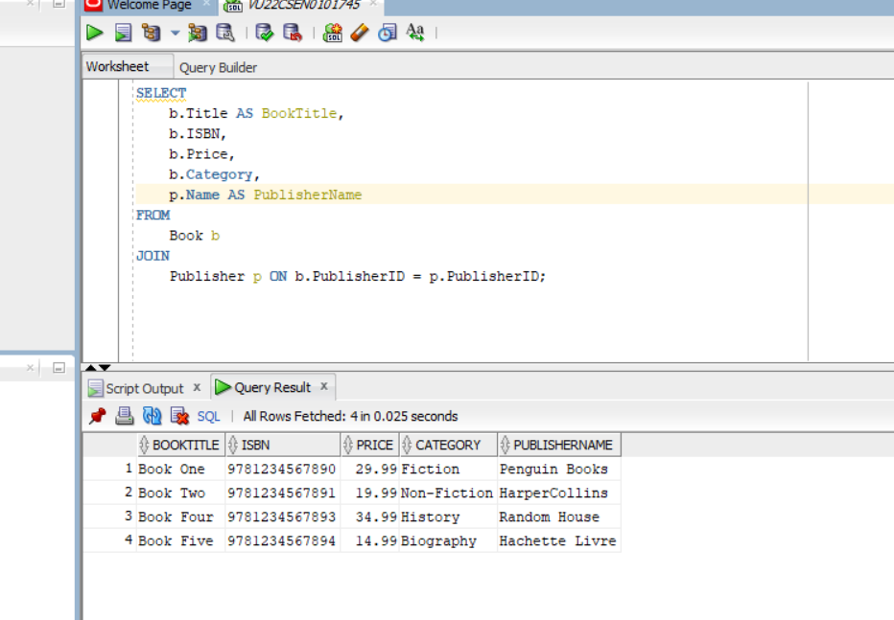

Join 3 : Get Reader Information Along with their Login Details   
  
  
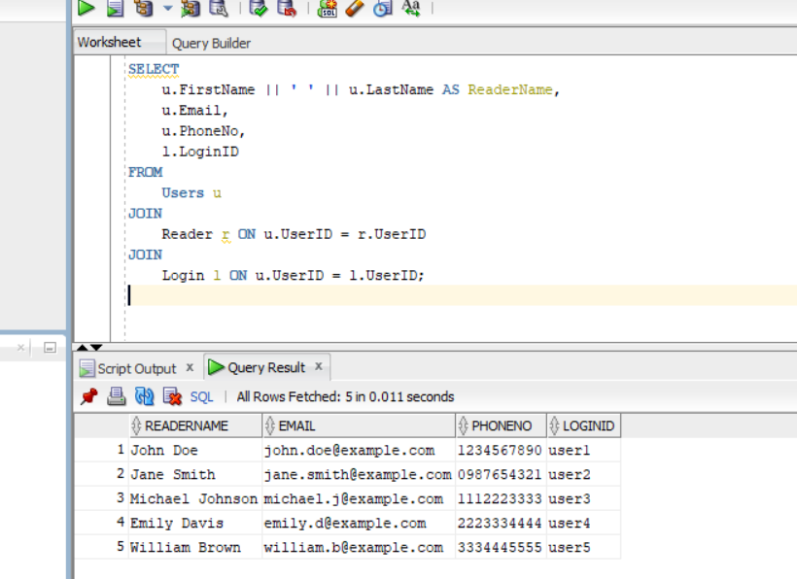

**Views :**

1. View for Issued Books view –   
     
   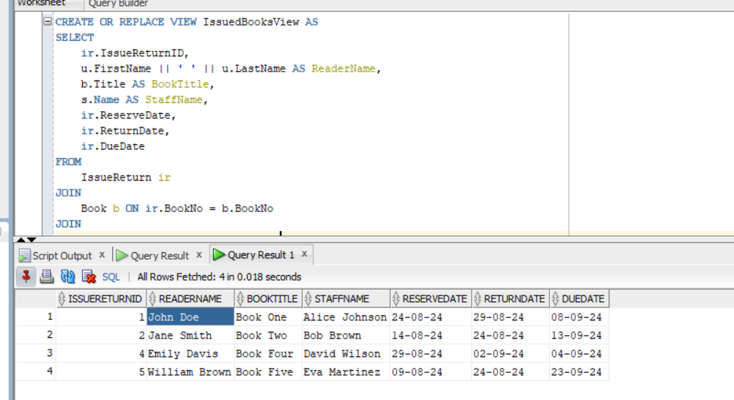
2. View for Books with Publisher Information  
     
   